Project Design Phase
Solution Architecture

Date | 15 February 2026
Team ID | LTVIP2026TMIDS52481
Project Name | Dog Breed Identification Using Transfer Learning
Maximum Marks | 4 Marks
Solution Architecture (Dog Breed Classification System)

Solution architecture for the Dog Breed Classification using Transfer Learning (MobileNetV2) project defines how the business need—automatic identification of dog breeds from images—is transformed into a scalable and efficient technical solution. It connects user requirements, deep learning models, and web deployment into a unified system.

The goals of this solution architecture are to:

Provide an intelligent technical solution that automatically classifies dog breeds from uploaded images using deep learning and transfer learning.

Describe the overall system structure, including data collection from Kaggle, image preprocessing, MobileNetV2-based model training, Flask web integration, and deployment using Hugging Face.

Define system features and workflow, such as user authentication, image upload, preprocessing, prediction generation, and result visualization through a web interface.

Establish development and deployment requirements, ensuring the model is trained, saved, integrated with the backend, and made accessible globally through cloud deployment.

Ensure scalability, accuracy, and usability, enabling fast predictions, reliable performance, and easy interaction for users such as pet owners, veterinarians, and adoption platforms.
Example - Solution Architecture Diagram:
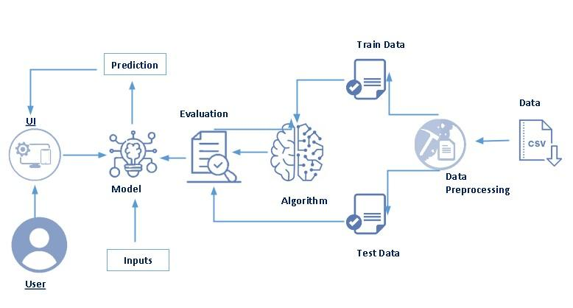
Figure 1: Architecture and data flow of the Dog Breed Identification with transfer learning

